**Lesson 7: Translating and Solving Equations**

**Do Now:**

**Do your best to solve these problems (Hint: try to express these equations into sentences, using what you learned from the previous lessons):**

1. **Find b if b+4 = 5 b = 1**
2. **Find c if c – 3 = 10 c = 13**
3. **Find a if 2a = 12 a = 6**
4. **Find d if d/3 = 12 d = 36**

**Key Vocabulary:**

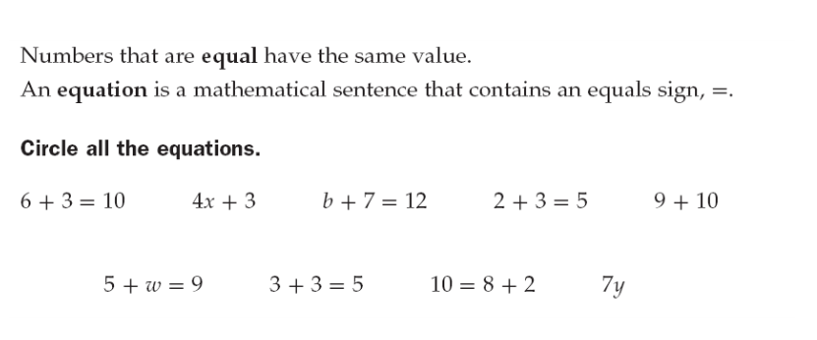

All of the above are equations except for 4x +3, 9+10, and 7y

**Guided Notes:**

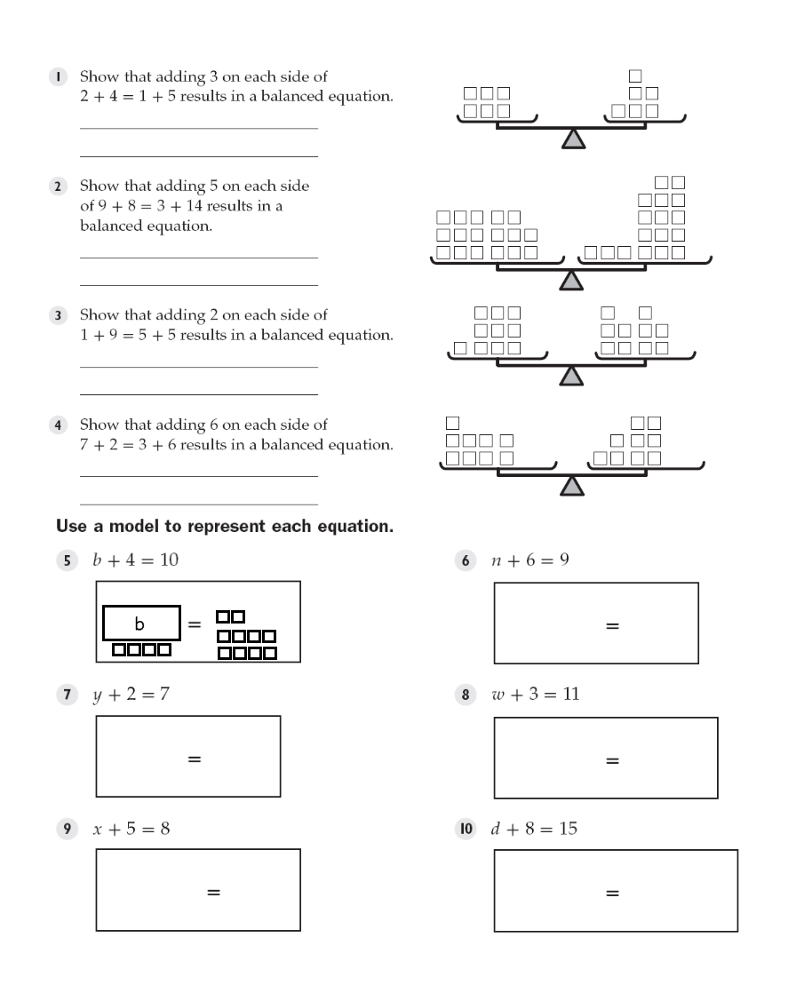

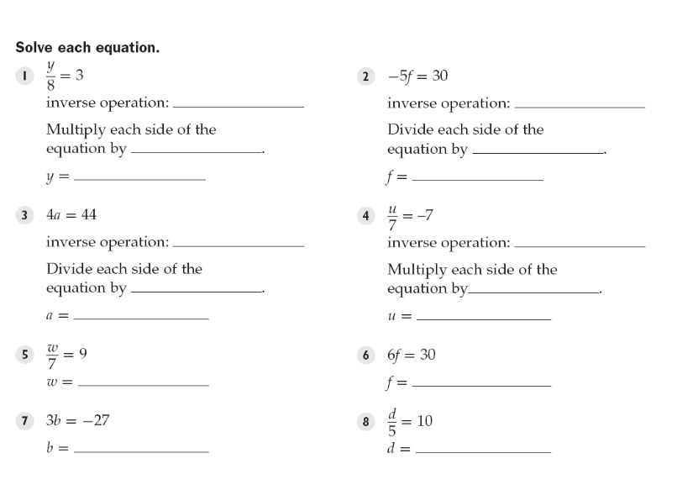

multiplication division

8 -5

24 -6

division multiplication

4 7

11 -49

63 5

-9 50

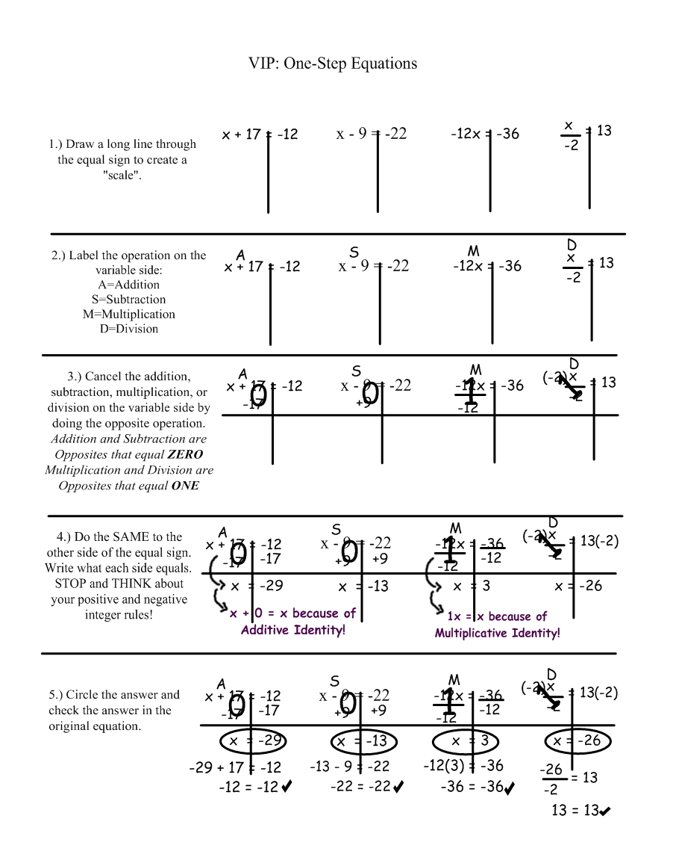

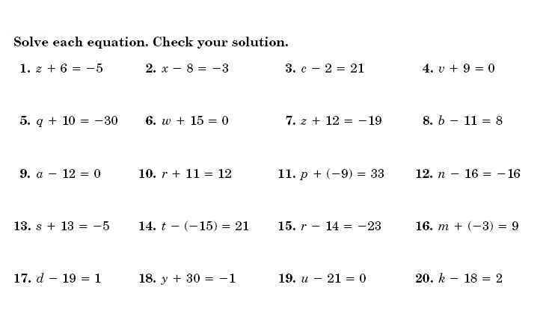

z = -11 x = 5 c = 23 v = -9

1 = -40 w = -15 z = -31 b = 19

a = 12 r = 1 p = 42 n = 0

s = -18 t = 6 r = -9 m = 12

d = 20 y = -31 u = 21 k = 20

y = 7 w = 48 u = 4 r = -75

d = -1 f = 0 n = -31 v = -98

b = -24 h = 6 r = -120 p = 18

x = -6 g = 5 z = -20 t = 0

g = -4 d = 4 m = -105 k = -1

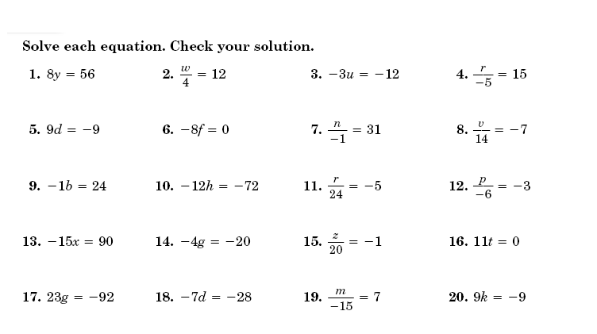

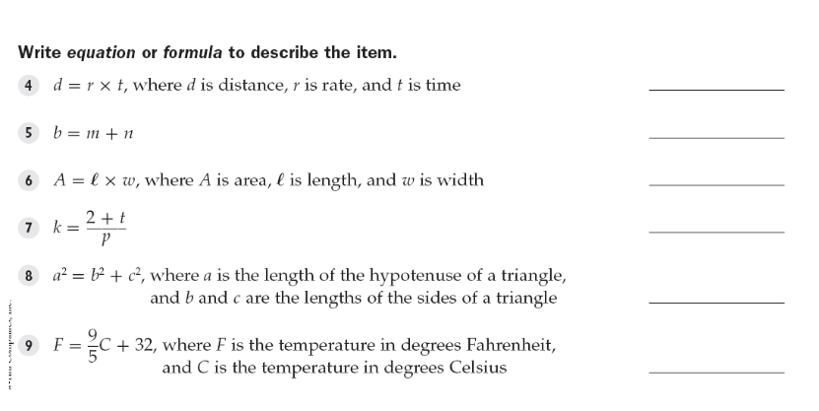

formula

equation

formula

equation

formula

formula

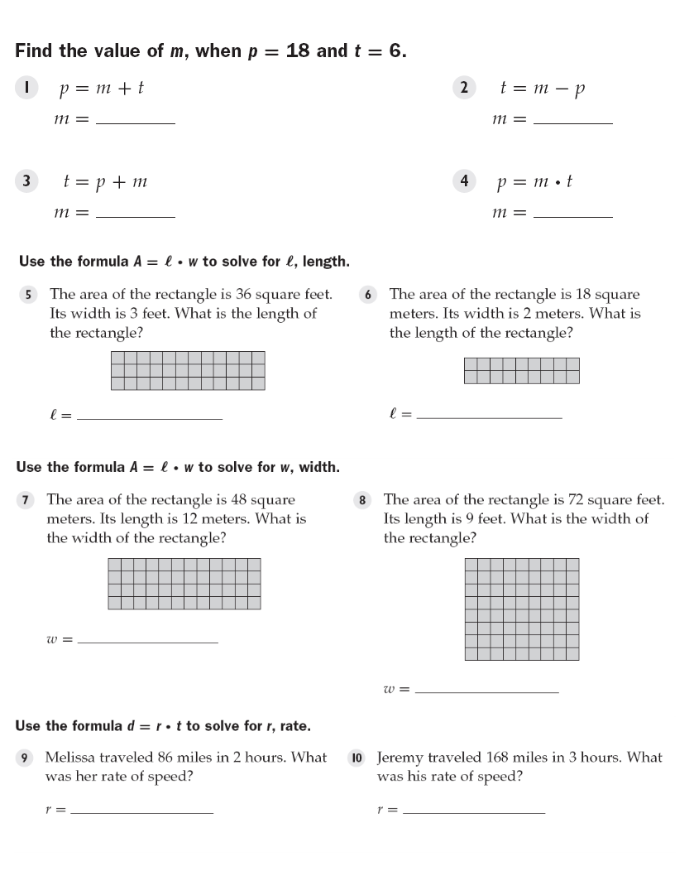

12 24

-12 3

12 feet 9 meters

4 meters

8 feet

43 mph 56 mph

**Structured/Guided Practice:**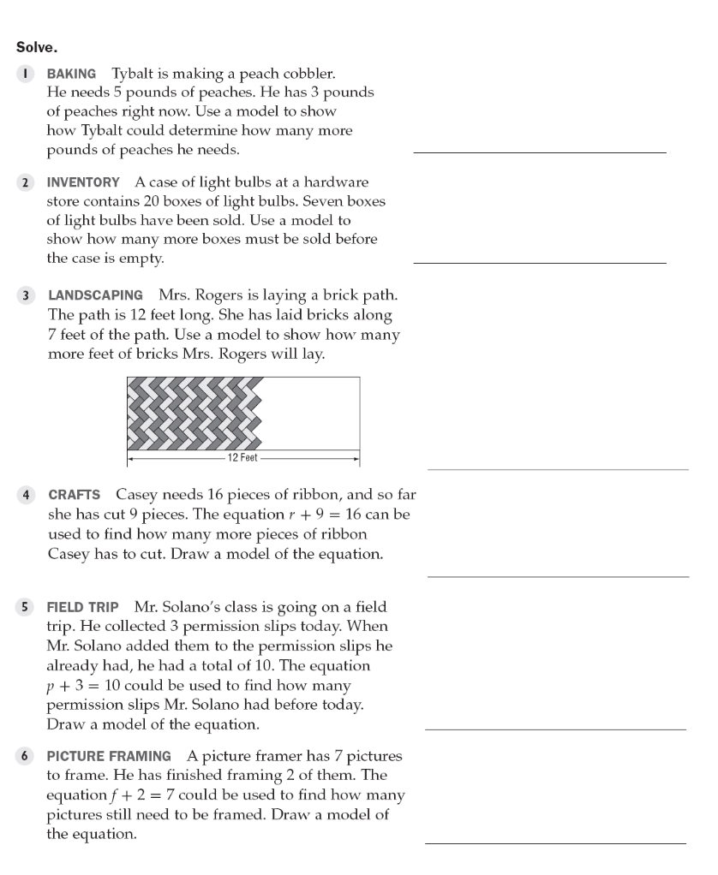

3 + p = 5

7 + b = 20

7 + p = 12

draw on your own

draw on your own

draw on your own

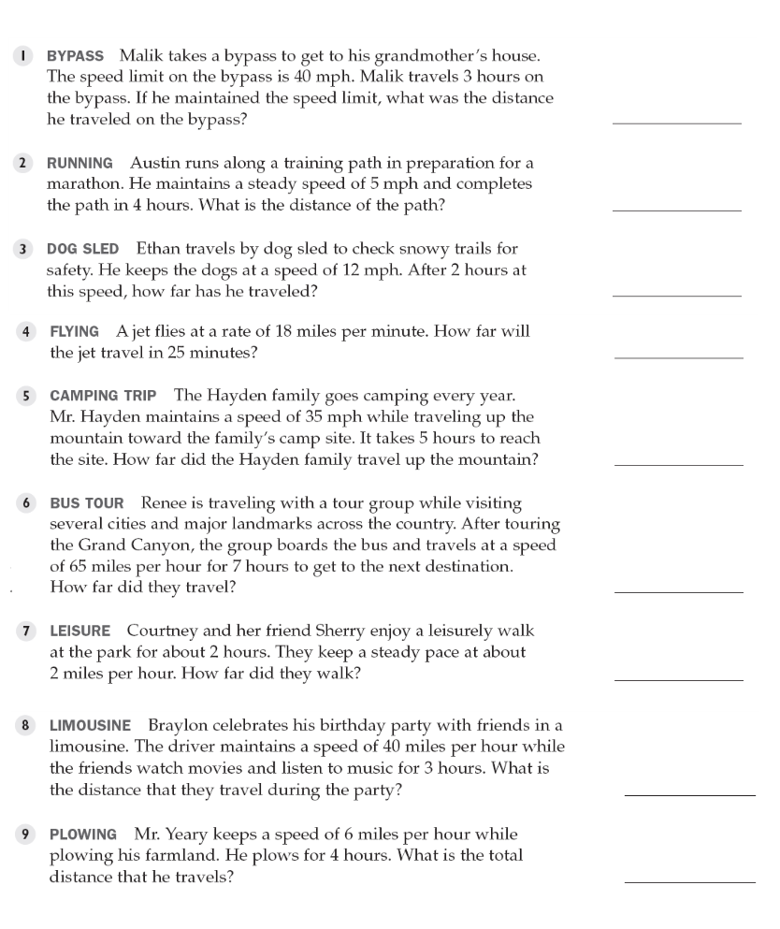

120 miles

20 miles

24 miles

450 miles

175 miles

455 miles

4 miles

120 miles

24 miles

**Independent Practice:**

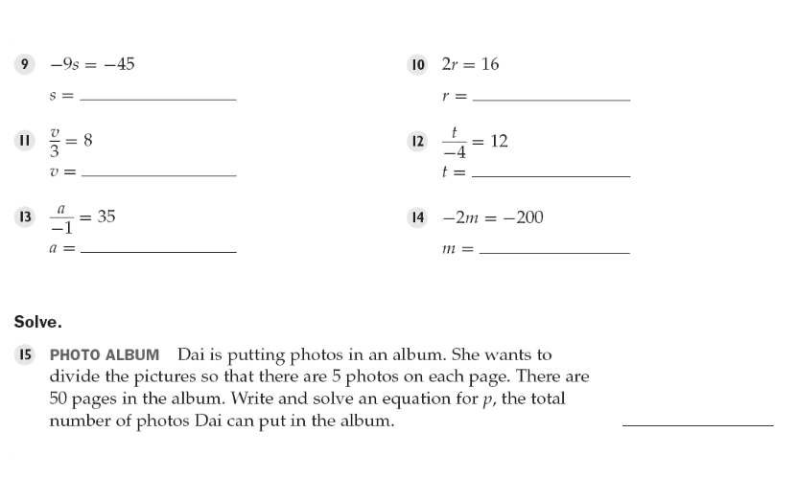

5 8

24 -48

-35 100

50/p = 5; p = 10

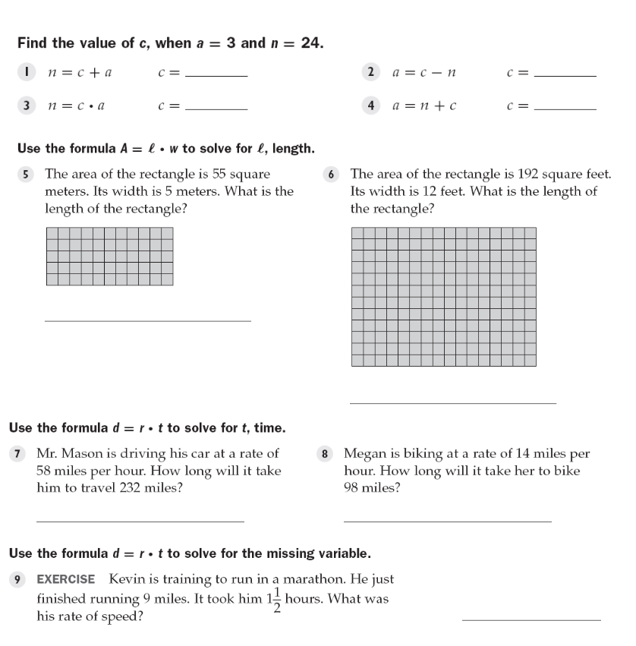

21 27

8 -21

11 meters

16 feet

4 hours 7 hours

6 mph

**Closure:**

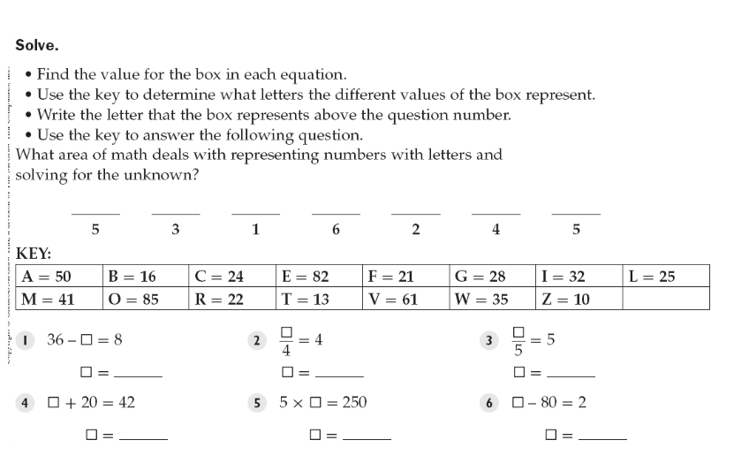

28 16 25

22 50 82

A L G E B R A